HYPER PARAMETER TUNING :

Hyper parameters are more like handles available to control the output or the behavior of the algorithm used for modeling. They can be supplied to algorithms as arguments. For eg: model= DecisionTreeClassifier(criterion=’entropy’), here the criterion entropy is the hyper parameter passed.

The function get_params() is the function used to get a list of all the hyper parameters for any algorithm.
When hyper parameters are not given to an algorithm, default values are picked to run the model. This makes hyper parameter tuning one of the critical steps involved in machine learning implementation.

GridSearchCV :
Grid Search is one of the most basic hyper parameter technique used and so their implementation is quite simple.
All possible permutations of the hyper parameters for a particular model are used to build models.
The performance of each model is evaluated and the best performing one is selected. Since GridSearchCV uses each and every combination to build and evaluate the model performance, this method is highly computational expensive.
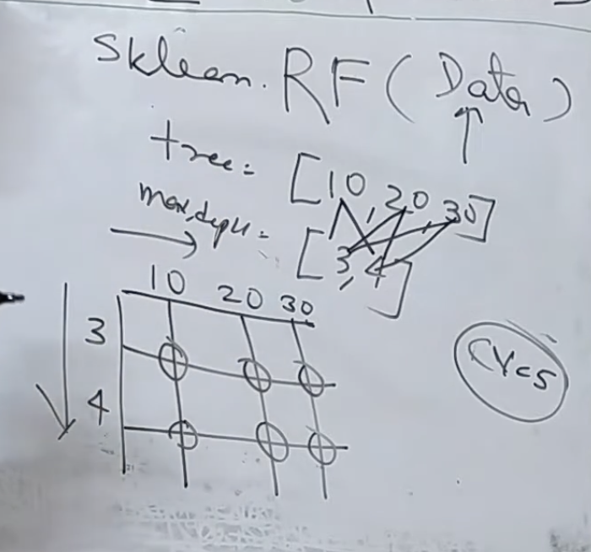
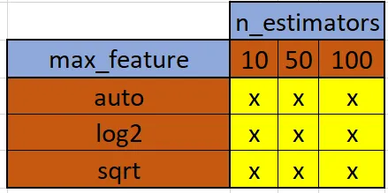

RandomizedSearchCV:
In randomizedsearchcv, instead of providing a discrete set of values to explore on each hyperparameter, we provide a statistical distribution or list of hyper parameters. Values for the different hyper parameters are picked up at random from this distribution.
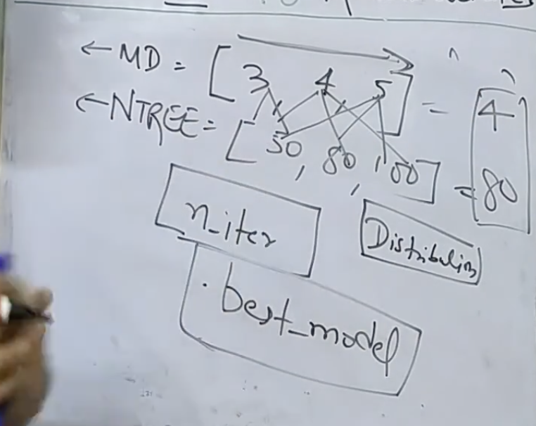

Practical Tuning Strategy

Step 1: Start with a baseline
model = RandomForestRegressor()
model.fit(X_train, y_train)

Step 2: Tune the MOST impactful parameters

Tree-based models:
- n_estimators → number of trees
- max_depth → overfitting control
- min_samples_split
- min_samples_leaf

Boosting (XGBoost / LightGBM):
- learning_rate (VERY important)
- n_estimators
- max_depth
- Subsample

Step 3: Use Random Search/GridSearchCV

Step 4: Analyze results
print(random_search.best_params_)
print(random_search.best_score_)

